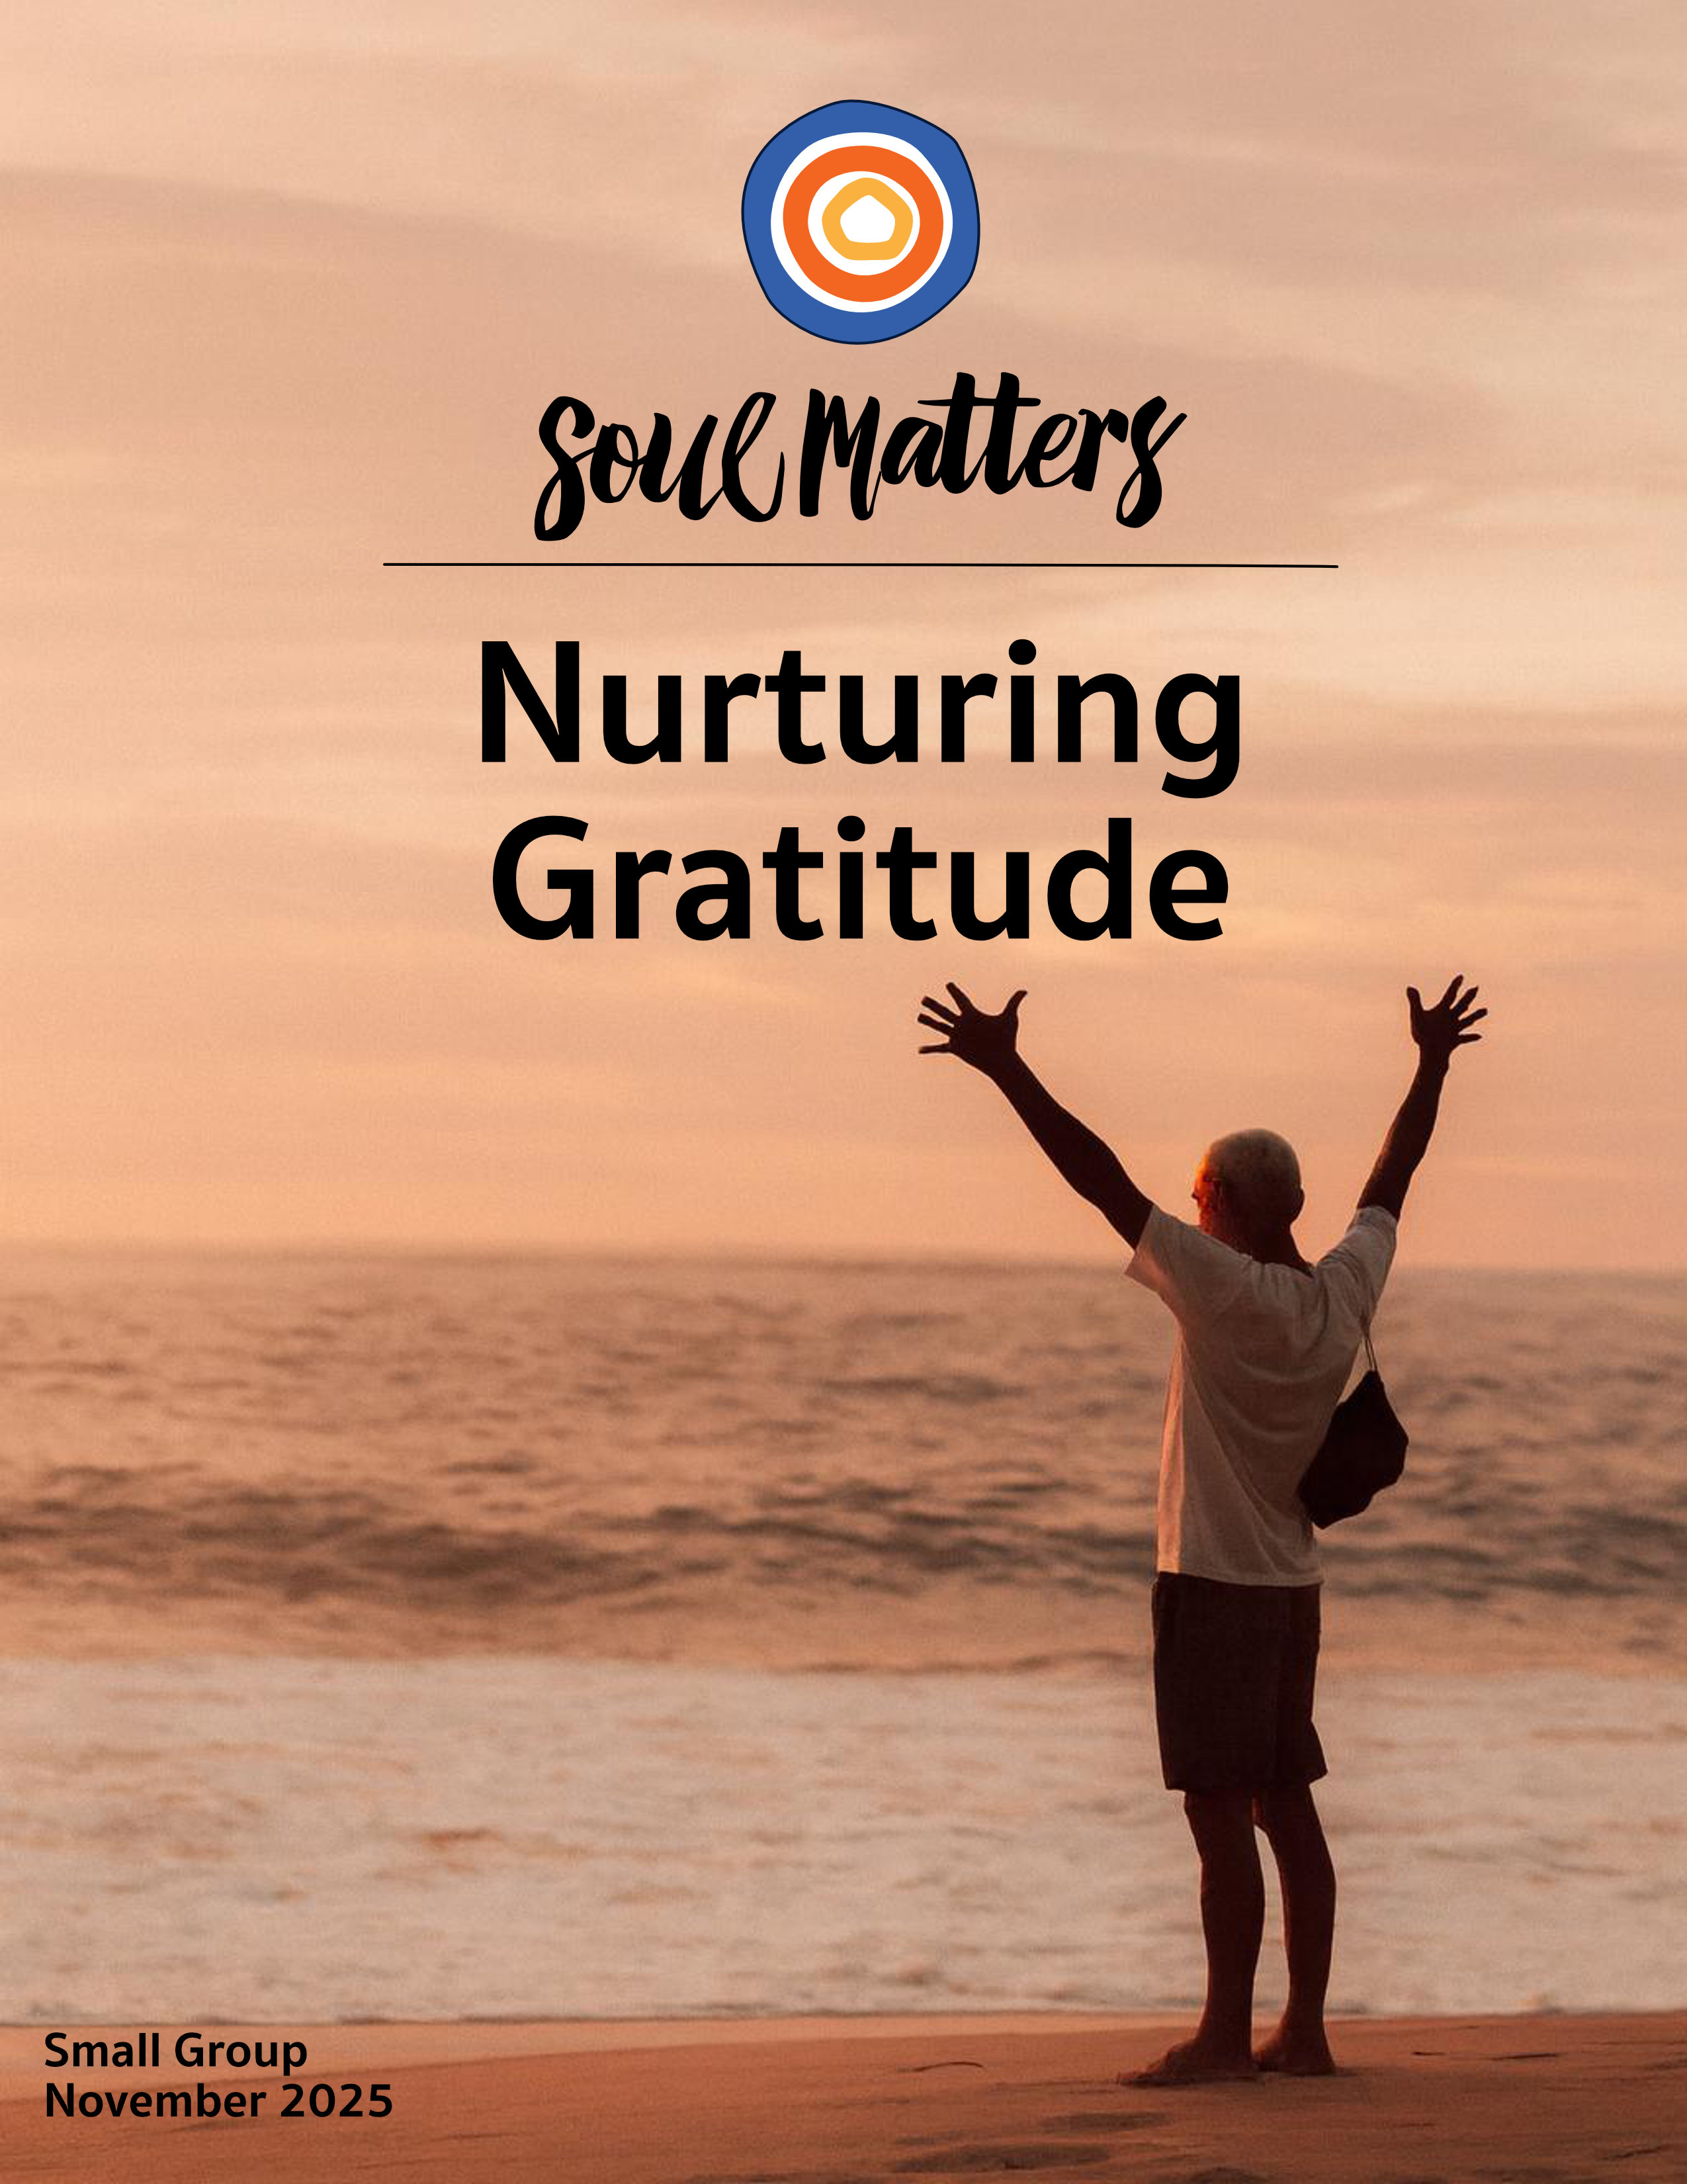

Welcome to Nurturing Gratitude

When it comes to how we should travel through our lives, our culture and religion are clearly at odds. Culture cries, “Accumulate!” Religion counsels “Appreciate!” The mantras couldn’t be more different: The commercials surrounding us scream, “Go out and grab all you can!” The pulpits before us plea, “Learn to want what you have.”

There’s an important reminder here: Gratitude is essential. It’s not simply a nice “extra” to get around to when we can. Or to put it another way, we aren’t built for constant striving and the pursuit of more. Instead, we need moments of pause in which we are filled and replenished by the large and small wonders of this world. As poet and philosopher, Mark Nepo, puts it: “The original meaning of the word “appreciate” means to move toward what is precious. So practicing gratitude reengages our aliveness—they awaken us to what is precious.” The implication here is clear: If we want to be truly alive, we need to pay attention when moments of gratitude arise.

But is that really it? Is that all we need to do? Wait for moments of gratitude to bloom and then stop and let their beauty sink in?

As our packet this month makes clear, many folks have their doubts. In one way or another, the voices within these pages point out that there is a big difference between appreciating the blessing of family and committing to sitting down together for dinner and intentionally sharing the blessings of one’s day. They go on to stress that it’s one thing to notice the beauty of nature; it’s quite another to pull yourself out of the rat race so you have time to enjoy it. And they certainly won’t let us forget that making a list of things we’re grateful for is impactful, but not nearly as powerful as the practice of “paying it forward.”

It’s all a way of gently pointing out that some of us practice gratitude passively and others actively. Or maybe the better way to put it is to say, gratitude needs our help! It can’t always flower all on its own, because there are serious threats out there: busyness, the lure of climbing the ladder, worries about the state of our world. They all work like weeds, suffocating and crowding out gratitude before it has a chance to sprout even the tiniest leaf.

Which means that maybe the most important part of this month’s theme is the "nurturing" part. Sitting back and waiting for gratitude to arise is simply not enough. That’s just not how gardens grow. If we listen carefully to the call of gratitude, we will hear a challenge to change our lives, not just appreciate them.

So friends, as we weave our way through this month’s journey, may we carry with us the question of “What do I need to do a better job of noticing?” But may we also not forget the possibly even more important question of “What practices of weeding does gratitude need from me?”

And as we hold both of those questions tight, may the blooming begin!

Spiritual Exercises
It’s one thing to analyze a theme; it’s quite another to experience it. By pulling us out of the space of thinking and into the space of doing, our spiritual exercises invite us to figure out not just what we have to say about life, but also what life has to say to us!

With that in mind, pick and complete the one exercise that speaks to you the most. Come to your group ready to share why you picked the exercise you did, how it surprised you and what gift it gave you.

Option A

A Photographic Gratitude List

Hailey Bartholomew is a photographer and film maker. During a low point in her life, she turned to a life-coach who invited her to try the traditional gratitude practice of ending each day by making a gratitude list - a list of the large and small gifts that that day blessed her with. It helped, but as a photographer, Hailey couldn’t resist putting her spin on it. Instead of making a list at the end of each day, she kept her camera at her side and captured the thing she was grateful for right in the moment. On top of that, she committed to doing this each day for an entire year! It became what she called The 365 Grateful Project.

There’s something especially powerful about this spin on the traditional gratitude list practice. Instead of pulling us back to the past, it pulls us more deeply into the present. Rather than “looking back,” we’re forced to look more closely. To photograph something, you have to pay attention to the details. And you have to linger on it and savor it in a way that you might not if you were just going about your day and noting it with your mind.

So, for one week - or even two! - keep your phone’s camera at the ready and, each day of that week, take one picture of something you are grateful for. Before you start, spend some time with Hailey’s story by visiting her website and watching this short video: https://www.youtube.com/watch?v=AedIvmd8MJA&t=196s

Option B

Your Poetic Gratitude List

Most gratitude lists are just that: lists. To a poet’s eye and ears, we can do so much better than that. Mary Oliver and Andrea Gibson are two prime examples. Oliver’s poem, Gratitude, and Gibson’s poem, Acceptance Speech Upon Setting the World Record in Goosebumps, are two of the most beautiful gratitude list poems out there.

Not only are they beautiful, but they are also replicable. So for this exercise, you are invited to follow their lead and write a poem using one of their poems as a template.

Mary Oliver’s Gratitude can be found here in written form and here in spoken form. To make your own version of it, write out her seven questions (What did you notice? What did you hear? etc.) and answer them each with short lists of your own. (You, of course, do not have to make all of your answers nature-orientated like Oliver does. But to honor her, throw in at least one or two nature-related answers of your own!)

Andrea Gibson’s Goosebumps can be found here in written form and here in spoken form. To make your own version of it, write out a bunch of short descriptions of precious experiences you’ve had and then designate each description with a goosebumps rating as she does. (Yes, figuring out your own goosebump rating scale is a huge part of the fun!)

Whichever poem you use to inspire and structure your own, remember that they are both there to help you unlock gratitude for your life in a new way. So come to your group ready to share what got unlocked in you.

Option C

A George Bailey Gratitude Exercise

With all due respect to the traditional gratitude list, recent research suggests that, for some of us, it just doesn’t work. Adding up everything we are grateful for just falls flat.

The good news is that, for those of us like this, researchers have discovered a new and more effective way of helping us feel the deep joy that gratitude brings. Instead of adding up the gifts in our lives, this approach invites us to subtract them! Instead of reflecting on the presence of a positive event in our lives (“I’m grateful I met my spouse”), you reflect on its absence (“What if I had never met my spouse?”).

Think of it as a counterfactual meditation on our lives, inviting us to imagine a world where our most treasured blessings never occurred. It’s basically what the angel in It’s a Wonderful Life famously asked George Bailey to do.

So, if you are one of those folks who never clicked with gratitude lists, give this a try:
- Set aside an hour some morning or evening.
- Watch these two videos: https://www.instagram.com/reel/DMWHWK3MPRq/ & https://www.youtube.com/watch?v=0OihoizDtkk
- Pick something central to your life. It can be something you consider a blessing, but this works just as well with something you are neutral or negative about. So it could be your spouse, your kid, a risk you once took like taking a gap year to travel or starting your own business, a physical aspect of yourself like your red hair, a hobby like playing an instrument or doing a sport, an injury you suffered, or even a loss.
- Imagine what your life would be like without this thing in your life. Play out what other things would not have happened if this thing about you didn’t exist. Make a list of those things.
- Spend some time with that list. Add to it and edit it as feels right. Once it feels finished, reflect on it, paying particular attention to what kind of feelings arose and what sparked those feelings.
- Finally, if you feel comfortable doing so, share the thing you picked to remove from your life and the list of things that would have disappeared with it. Who should you share it with? Trust us, you will know.

Option D

Tell The Story of Your “Gift Hat”

Conceiving of something as a gift changes your relationship to it in a profound way, even though the physical makeup of the “thing” has not changed. A woolly knit hat that you purchase at the store will keep you warm regardless of its origin, but if it was hand knit by your favorite auntie, then you are in relationship to that “thing” in a very different way: you are responsible for it, and your gratitude has motive force in the world. You’re likely to take much better care of the gift hat than the commodity hat, because it is knit of relationships. - Robin Wall Kimmerer

Your “gift hat” may not be a hat, but we all have one. And we all know exactly what Kimmerer is talking about. There are things in our life that carry a different weight for us and compel a different kind of responsibility from us than the commodities in our life.

This exercise simply asks you to revisit that gift through the lens of Kimmerer’s quote and then come to your group ready to tell the story of how your gift came into your life and what it has come to mean to you. (And even better, bring the gift with you if you can!)

Option E

Ask Them About Gratitude

One of the best ways to explore our monthly themes is to have conversations about them with people who are close to you. It’s also a great way to deepen our relationships! Below is a list of questions to guide your conversation. Be sure to let your conversation partner know in advance that this won’t be a typical conversation. Telling them a bit about Soul Matters will help set the stage. Remember to also answer the questions yourself as they are meant to support a conversation, not just a time of quizzing them.

Come to your group ready to share what surprised you about the conversation and what gift or insight it gave you. As always, keep a lookout for how your inner voice is trying to send you a message of comfort or challenge through these conversions with others.

Gratitude Questions:

- What’s the luckiest thing that ever happened to you? And if you could talk to and thank that lucky event, what would you say?
- Which childhood experience are you most grateful for?
- Which of your senses are you most grateful for at this stage of your life?
- Has gratitude ever guided you through or rescued you from grief?
- Who is the most grateful person you know? What part of them has rubbed off on you?
- Which person in your life do you wish gratitude came more easily to?
- What has life taught you about the power of appreciating others and telling them thank you?
- What period of your life was gratitude most absent? What period was it most present?
- When was the last time you were grateful for yourself?
- What wakes you up to the gift of it all?

Option F

Which Companion Piece Speaks to You?

Sometimes we come across a quote, song, article or movie and it perfectly captures what’s going on for us right
now or allows us to view our current circumstances in a new light.

With this in mind, spend some time this month going through the Companion Pieces section below to find the
one piece that speaks most powerfully to you. (Or “shimmers” most strongly for you.)

Come to your group ready to share the piece you picked, why it called to you and what insight, memory, or message of comfort or challenge it offered you.

Finding Your Question

This list of questions is an aid for deep reflection. How you answer them is often less important than the journey they take you on.

So, read through the list of questions 2-3 times until one question sticks out for you and captures your attention, or as some faith traditions say, until one of the questions “shimmers.” Or as we like to say, “Read over them until one of the questions picks you.”

Then reflect on that question using one or all of these questions:
- What is going on in my life right now that makes this question so pronounced for me?
- What might my inner wisdom be trying to say to me through this question?
- How might this question be trying to wake me up or get me to realize something through this question?
- How might Life or my inner wisdom be trying to offer me a word of comfort or challenge through this question?


- When was the last time you were grateful for yourself?
- Which childhood experience are you most grateful for?
- Is there something you used to be grateful for that you now take for granted? What would it take to view it with fresh eyes?
- You are aware that your life is someone else’s dream, right?
- What would happen if you turned all of your “I have to’s” into “I get to’s”?
- How would your life change if you paused to reflect on how many things you have now that were things you only dreamt of a decade ago?
- How good are you at receiving thanks?
- Autumn leaves burn bright with color, but if you blink, they are gone. So, what temporary blaze of beauty do you need to give your gratitude and attention to before time runs out?
- Have you mistaken gratitude for a “feeling” rather than a practice? Or to put it another way, do you wait for gratitude to arise rather than proactively find ways to cultivate it?
- What wakes you up to the gift of it all?
- The most difficult gifts to be grateful for are the gifts given to us by our suffering and losses. Have you found the gift in the thing you wished hadn’t happened?
- So life’s led you into a puddle. Are you still staring at your mud-covered feet? Or are you ready to look up and notice that the wide-open sky never went away?
- Might gratitude for your life increase if you lessened how much you compare it to the lives of others?
- How might gratitude be calling you to shift your thanks from what is extraordinary and rare to what is abundantly ordinary?
- What’s your question? Your question may not be listed above. As always, if the above questions don't include what life is asking from you, spend the month listening to your days to find it.

Companion Pieces

Recommended Resources for Personal Exploration & Reflection

The following resources are not required reading. Nor are they intended to be analyzed in your group.
Instead, they are here to companion you on your personal journey this month, get you thinking
and open you up to new ways of embodying this month’s theme in your living and loving.

Word Roots & Definitions

Gratitude has the same Latin root as kindness and grace. Its old English meaning was “a readiness to return kindness.” These connections invite us to think of gratitude as a way to usher more kindness into the world. Additionally, its connection to grace calls us to recognize what we receive from the world as a gift rather than as an entitlement.

Wise Words

The original meaning of the word “appreciate” means to move toward what is precious. Practicing gratitude is a type of leaning in towards being truly present. It’s a practice that reengages our aliveness—that awakens us to what is precious.
Mark Nepo

We enter the world as strangers who all at once become heirs to a harvest of memory, spirit, and dream that has long preceded us and will now enfold, nourish, and sustain us. The gift of the world is our first blessing.
John O'Donohue

There is no wealth but life.
John Ruskin

It could happen any time, tornado, earthquake… Or sunshine, love, salvation… That’s why we wake and look out — no guarantees in this life. But some bonuses, like morning, like right now.
William Stafford

Your normal day is someone else's dream.
Anonymous

It’s not what we have that constitutes our abundance, but what we appreciate.
Jean Antoine Petit-Senn

So much has been given to me; I have no time to ponder over that which has been denied.
Helen Keller

Happiness does not make us grateful, gratefulness makes us happy.
David Steindl-Rast

Gratitude places you in the energy field of plenitude. Perceiving life in a consciousness of gratitude is literally stepping into another dimension of living. Suddenly the seeming ordinariness of your days takes on a divine sparkle.
Michael Beckwith

Don’t misuse your mind. Don’t say there isn’t anything extraordinary here.
The Blue Cliff Record

If our first response to the receipt of gifts is gratitude, then our second is reciprocity: to give a gift in return… When I speak about reciprocity as a relationship, let me be clear. I don’t mean a bilateral exchange in which an obligation is incurred, and can then be discharged with a reciprocal “payment.” I mean keeping the gift in motion in a way that is and diffuse, so that the gift does not accumulate and stagnate, but keeps moving.
Robin Wall Kimmerer, The Serviceberry

A hundred times every day I remind myself that my inner and outer life are based on the labors of others, living and dead, and that I must exert myself in order to give in the same measure as I have received and am still receiving.
Albert Einstein

When eating a fruit, think of the person who planted the tree.
Vietnamese Proverb
Feeling gratitude and not expressing it, is like wrapping a present and not giving it.
William Arthur Ward

We should be especially grateful for having to deal with annoying people and difficult situations, because without them we would have nothing to work with. Without them, how could we practice patience, exertion, mindfulness, loving-kindness or compassion? It is by dealing with such challenges that we grow and develop. So we should be very grateful to have them.
Judy Lief

If you find yourself… hearing, again, the earth's great, sonorous moan that says… all you love will turn to dust… Do not raise your small voice against it… Instead, curl your toes into the grass… Walk through the garden's dormant splendor. Say only, thank you.
Ross Gay

You will lose everything. Your money, your power, your fame, your success, perhaps even your memories… But that which will be lost has not yet been lost, and realizing this is the key to unspeakable joy… Impermanence has already rendered everything and everyone around you so deeply holy and significant and worthy of your heartbreaking gratitude. Loss has already transfigured your life into an altar.
Jeff Foster

When you are with someone who has developed the habit of gratitude, you SO want what they have. They are not grasping for more. They are savoring, shaking their heads slightly with the quietest wonder.
Anne Lamott

You wander from room to room, hunting for the diamond necklace that is already around your neck!
Rumi

Gratitude unlocks the fullness of life. It turns what we have into enough, and more. It can turn a meal into a feast, a house into a home, a stranger into a friend.
Melody Beattie
The worst possible thing you can do when you’re down in the dumps, tweaking, vaporous with victimized self-righteousness, or bored, is to take a walk with dying friends. They will ruin everything for you.

Friends like this may not even think of themselves as dying, although they clearly are… No, they see themselves as fully alive. They are living and doing as much as they can, as well as they can, for as long as they can.

They ruin your multitasking high, the bath of agitation, rumination, and judgment you wallow in, without the decency to come out and just say anything. They bust you by being grateful for the day, while you are obsessed with how thin your lashes have become and how wide your bottom.
Anne Lamott

With gratitude, optimism is sustainable. If you can find something to be grateful for then you can find something to look forward to, and you can carry on.
Michael J. Fox

While we cry ourselves to sleep, gratitude waits patiently to console and reassure us that there is a landscape larger than the one we can see.
Sarah Ban Breathnach

It is a slightly arresting notion that if you were to pick yourself apart with tweezers, one atom at a time, you would produce a mound of fine atomic dust, none of which had ever been alive but all of which had once been you. Yet somehow for the period of your existence they will answer to a single overarching impulse: to keep you you.
Bill Bryson

Music
Our thematic playlists - on Spotify and YouTube - are organized as a journey, so consider listening from beginning to end and using them as a personal musical meditation.

Click here for the Spotify playlist on Nurturing Gratitude
Click here for the YouTube playlist on Nurturing Gratitude

Videos & Podcasts

Because… Andrea Gibson
https://www.instagram.com/reel/C9ISC0kOrW6/

Just pause and ask yourself… Trevor Noah
https://www.instagram.com/thoughtsmagnet/reel/DC-cB9TyEQv/

Blessing For Sound and Light, David Whyte
https://vimeo.com/639146289?embedded=true&source=video_title&owner=1022824

The Gratitude Time Machine Practice
https://www.instagram.com/p/C6uYo9dojcP/

On Gratitude as Our Guide Through Grief
https://www.youtube.com/watch?v=l860_0ZBhb4

What Punishments of God are not Gifts?, Stephen Colbert
https://www.instagram.com/p/DFs03uxOCsC/

Confessions on Gratitude, Jonathan Mendoza
https://www.youtube.com/watch?v=MUHHVKU_L9A

Grateful Voices, Claire
https://www.youtube.com/watch?v=qircCsSHO7A

Thank You, Ross Gay
https://www.tiktok.com/@moongladecommons/video/7498759145743502638

Thanks, W.S. Merwin
https://www.instagram.com/reel/DNBUfQjsbNv/

On Ordinary Gifts & Gratitude for All of Life
https://www.youtube.com/watch?v=jNVPalNZD_I

Acceptance Speech after Setting the World Record in Goosebumps, Andrea Gibson
https://www.youtube.com/watch?v=4XK-hb_bjqU

More of This - The Sanctuary Boston
https://www.youtube.com/watch?v=rDZ7ug1eEzU
Articles

Returning the Gift, Robin Wall Kimmerer
On Indigenous Wisdom and Gratitude
https://grateful.org/resource/returning-the-gift/

A Thanksgiving Message from Seven Amazing Native Americans
https://www.project562.com/blog/a-thanksgiving-message-from-seven-amazing-native-americans

Books

The Serviceberry: Abundance and Reciprocity in the Natural World
Robin Wall Kimmerer

Wake Up Grateful: The Transformative Practice of Taking Nothing for Granted
Kristi Nelson

Catalog of Unabashed Gratitude
Ross Gay

The Unlikely Pilgrimage of Harold Fry
Rachel Joyce

Movies

The Life of Chuck
A Man Called Ove
Gratitude Revealed
Forrest Gump
The Gift


© 2025-26 Soul Matters ALL RIGHTS RESERVED
Packets are for use ONLY by member congregations of the Soul Matters Sharing Circle.
Learn how to join at https://www.soulmatterssharingcircle.com

