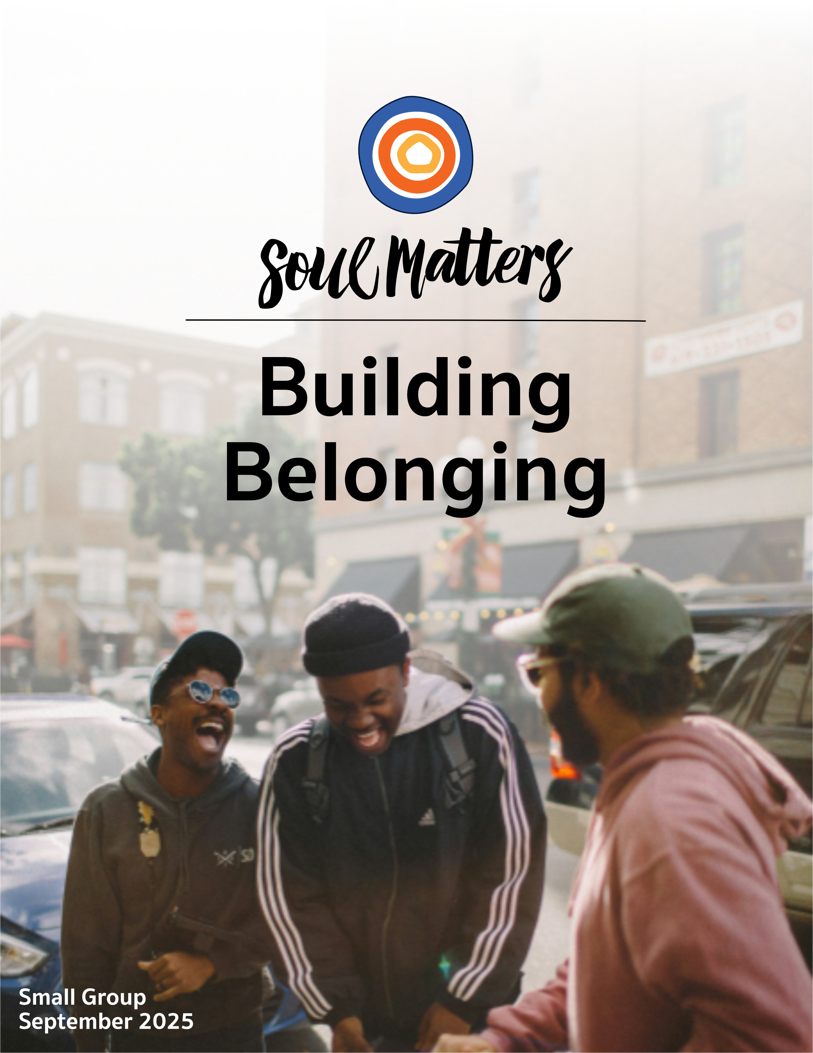

Welcome to Building Belonging

Don’t surrender your loneliness so quickly.
Let it cut more deep.
Let it ferment and season you
as few human or even divine ingredients can.
Something missing in my heart tonight
has made my eyes so soft
my voice so tender
my need of god
absolutely clear.
Daniel Ladinsky, inspired by an original piece by the Sufi poet Hafiz.

Let loneliness cut more deep? It’s an odd place to start a month on building belonging. Maybe even an insensitive place, given how many of us have suffered and suffocated under loneliness’ weight.

But notice how the poem turns quickly to talk of a softening, tenderness and something missing in the heart. It’s apparent that a different kind of loneliness is being pointed to. A kind that has to do with a painful inner longing rather than the typical external-oriented sadness of not finding friends.

It brings to mind something said by the spiritual writer, Toko-Pa Turner,

Our longing for community is so powerful that it can drive us to join groups, relationships, or systems of belief that give a false impression of belonging. These places of false belonging grant us conditional membership, requiring us to cut parts of ourselves off in order to fit in.

So what if loneliness is sometimes a cry from one of these cut off pieces? What if sometimes the pain of loneliness is one of our buried parts pleading to belong to the rest of who we are? What if loneliness is quite often a sacred inner discomfort trying to push, pull and prod us back to wholeness?

Opening ourselves to this other kind of loneliness seems especially important given the dominant trends in this culture of ours, where the marginalized among us are pressured to twist and shape-shift ourselves into smaller beings in order to be acceptable to our racist and homophobic society, and where now our whole culture is “social media-ized,” pressuring all of us - in one way or another - to shave off our rough and imperfect edges and present ourselves as polished people who’ve got it all together.

To focus on such things is to wonder if, maybe without us fully noticing it, our whole society has become a land of lonely belonging, where no one is allowed to live without burying at least one part of themselves. The words of Carl Jung capture this well. He wrote, “Loneliness does not come from having no people around, but from being unable to communicate the things that seem important to oneself.”

So where does this leave us? Well, perhaps it’s an invitation to understand that the work of belonging begins with developing an intimate relationship with its opposite: loneliness. And opening ourselves to the idea that loneliness may not always be just a burden, emptiness or a source of depletion, even though it can feel that way. Maybe sometimes loneliness is also a source of wisdom, arising from a caretaking part of us trying to tell us “This is not the way to live!”

So, friends, this month let’s listen to our loneliness more closely. Because it appears to be the key to the unique kind of belonging that each of us needs.

Spiritual Exercises
It’s one thing to analyze a theme; it’s quite another to experience it. By pulling us out of the space of thinking and into the space of doing, our spiritual exercises invite us to figure out not just what we have to say about life, but also what life has to say to us!

With that in mind, pick and complete the one exercise that speaks to you the most. Come to your group ready to share why you picked the exercise you did, how it surprised you and what gift it gave you.

Option A

The Circle of Belonging that Stands Out

We all have belonged to at least one community in our life that stands out, that offered us a rare and especially impactful gift that we will never forget, whether that be your church community, book club, circle of college friends, army squad, high school bandmates, or little league baseball team.

But often our appreciation for that community stays at the general level. We rarely take the time to tease out the detailed gifts it gave us. Or to put it another way, we rarely allow ourselves to embrace the full gift that circle of belonging gave us.

Embracing the full gift is what this exercise is all about. Below are a handful of sentences for you to complete. Each sentence is designed to bring a dimension of your relationship with your special community into sharper focus… and into your heart more deeply.

After finishing each sentence, take some time to reflect on any new insight or gift you gained from it. When you are all done, look back on all of the sentences and identify the one that stands out for you and why.

Sentences to Complete (click here to print out sentences)

- Before I found this community/group, I was…
- Before I found this community/group, I saw myself as…
- It was __________(luck, effort, time, grace, etc.) that led me to this community/group.
- While everyone in the community/group mattered deeply, the two people who especially made the community/group what it was were __________ and __________.
- If I had not had this community/group in my life, I would have…
- This community/group changed me from a person who __________ into a person who __________.
- When I think back on my memories of belonging to this group, the moment that stands out is…
- The thing that made this community/group unique was…
- At the time, I don’t think I fully understood how this group was…
- If I could go back and change one thing about my time with this community/group, it would be…
- The way we handled conflict also made this group unique. For example, there was the time when…
- If this community/group was a weather pattern, it would be a __________.
- If it was possible for me to gather the community/group together again and say thank you, I would say…

Option B

A Few Favorite Things about Yourself

Self-belonging is about self-love. And at its core, self-love is about being in touch with what you enjoy and treasure about yourself. So for your exercise this month, identify two of your favorite things about yourself. Odds are you’ve not given this much thought before. Most of us don’t. But here’s our promise: If you do give it a bit more thought, there is a gift of, not only self-belonging, but also freedom waiting on the other end.

All this will make more sense if you start things off by listening to this video clip: https://www.facebook.com/watch/?v=1215744403343558

After watching the clip, get going on figuring out your two things. And just like Jason Reynolds from the clip, don’t just name your two favorite things about yourself, also tease out why exactly that is the case.

Come to your group ready to share how the exercise surprised you most and what gift it gave you.

Option C

Compliments that Call Us into Belonging

The connection between compliments and belonging is often overlooked. In our culture, compliments are not talked about, or they are used to manipulate others to get something from them or to get them to do something we want them to do. Think of your boss who compliments you to keep you “motivated.”

But done with authenticity and a bit of skill, compliments create belonging in so many ways. For instance, they alter the atmosphere around the one we compliment, leaving them consciously or unconsciously feeling as though they now belong to a world where positivity and wishing each other well reigns rather than a world where competition and isolation rules. Compliments also alter the self one belongs to. When we notice and lift up someone’s specific actions or qualities, we don’t just help them feel seen, we wake them up to the uniqueness of who they are.

To honor this and sharpen our compliment skills, go out of your way this month to compliment strangers and friends. Remember it doesn’t have to be overly complicated. Simple compliments make a big impact.

To help you on your way, here is a playful but powerful example of compliments in action:
https://www.youtube.com/watch?v=bDxTJnkOa60

And here is some advice about how to give a compliment that connects:
- https://www.oprahdaily.com/life/relationships-love/a28221845/how-to-give-compliments/
- https://www.youtube.com/watch?v=doisC3SD10s
- https://time.com/6963181/how-to-give-good-compliments/

Option D

The Story of a Belonging You Belong To

There are certain things that we belong to as much as - if not more than - they belong to us. Just think about your dad’s watch, your raggedy sweatshirt with your college’s mascot on it, that special Christmas tree ornament your child made in 2nd grade, that Star Wars figurine from your childhood or that mixed tape you made for your spouse when you were first dating. We hold on to these things because they hold the stories of our lives. They aren’t simply belongings; they are a record of the life we belong to.

To honor this, take some time this month to identify one of these special belongings and then bring it (or a picture of it) into your group along with the story of how it came into your possession and how it helps you stay connected to a precious piece of your life. Before you get going on this exercise, watch this video for inspiration: https://www.youtube.com/watch?v=-gEEHpNhbtw

Option E

Ask Them About Belonging

One of the best ways to explore our monthly themes is to have conversations about them with people who are
close to you. It’s also a great way to deepen our relationships! Below is a list of questions to guide your conversation. Be sure to let your conversation partner know in advance that this won’t be a typical conversation. And remember to answer the questions yourself as they are meant to support a conversation, not just a time of quizzing someone else. Come to your group ready to share what surprised you about the conversation and what gift or insight it gave you.

Belonging Questions

- What life has taught you about loneliness?
- When was the first time you thought to yourself, “Now I belong”?
- What food reminds you of belonging?
- Where does your sense of belonging live in your body?
- Has belonging gotten easier or harder as you’ve grown older?
- What is the greatest lie that our culture tells us about belonging?
- Have you ever had to sacrifice belonging for integrity? Or your integrity for belonging?
- Has loneliness ever tried to protect you?
- What pieces of your religious past do you wish still belonged to you?
- How might we deepen our sense of belonging to each other?

Option F

Which Companion Piece Speaks to You?
Sometimes we come across a quote, song, article or movie and it perfectly captures what’s going on for us right
now or allows us to view our current circumstances in a new light. With this in mind, spend some time this month going through the Companion Pieces section below to find the one piece that speaks most powerfully to you. (Or “shimmers” most strongly for you.)

Come to your group ready to share the piece you picked, why it called to you and what insight, memory, or message of comfort or challenge it offered you.

Finding Your Question

This list of questions is an aid for deep reflection. How you answer them is often less important than the journey they take you on.

So, read through the list of questions 2-3 times until one question sticks out for you and captures your attention, or as some faith traditions say, until one of the questions “shimmers.” Or as we like to say, “Read over them until one of the questions picks you.”

Then reflect on that question using one or all of these questions:
- What is going on in my life right now that makes this question so pronounced for me?
- What might my inner wisdom be trying to say to me through this question?
- How might this question be trying to wake me up or get me to realize something through this question?
- How might Life or my inner wisdom be trying to offer me a word of comfort or challenge through this question?



- What is your favorite memory of childhood belonging? How does that moment still live in you today?
- Do you remember the moment when you knew for certain that you no longer belonged to childhood, the moment when you knew your childhood was over and that you were now, without doubt, a grown-up? How did the uniqueness of that moment shape who you are?
- Of all the communities you have belonged to, which is your favorite? If you could say thank you to it, what would you say?
- What aspect of your personality do you need to do a better job of embracing and welcoming in? Your judgmental self? Your lazy self? Your vulnerable self? Your bitter self? Your easily frightened self? Your quick-to-anger self? Your jealous self? Your petty self? Your selfish self?
- What long hoped-for life do you need to let go of in order for you to belong to the life right in front of you?
- Has loneliness ever tried to protect you?
- Do you know what it is like to be in a community or relationship that requires you to remove or deny parts of yourself to belong?
- What gift did your “chosen family” give you that your family of origin didn’t or couldn’t?
- What is the greatest lie that our culture tells us about belonging?
- Some of us live in a place and others of us belong to a place. How does the place you belong to carry your stories, make room for your pain and keep you in touch with your longings?
- Self-belonging is about self-love. So…what if you are the love of your life?
- What failure are you glad you belong to?
- Have you settled for belonging to people who include you when your heart longs to be surrounded by people who adore you?
- What’s your question? Your question may not be listed above. As always, if the above questions don't include what life is asking from you, spend the month listening to your days to find it.

Companion Pieces
Recommended Resources for Personal Exploration & Reflection
The following resources are not required reading. Nor are they intended to be analyzed in your group.
Instead, they are here to companion you on your personal journey this month, get you thinking
and open you up to new ways of embodying this month’s theme in your living and loving.

Wise Words

One of the most important things you can do on this earth is to let people know they are not alone.
Shannon L. Alder

We are biologically, cognitively, physically, and spiritually wired to love, to be loved, and to belong. When those needs are not met, we don’t function as we were meant to. We break. We fall apart. We numb. We ache. We hurt others. We get sick.
Brené Brown

Without community there is no liberation, only the most vulnerable and temporary armistice between an individual and her oppression.
Audre Lorde

Where you belong is where you choose to constantly choose to show up.
Karina Antonopoulos

I was so shocked to learn that the opposite of belonging is fitting in. Because fitting in is
assessing a group of people and changing who you are. But true belonging never asks us to
change who we are. It demands we be who we are.”
Brené Brown

Locate the kind of belonging that doesn’t demand your erasure.
Cole Authur Riley

Our longing for community is so powerful that it can drive us to join groups, relationships, or systems of belief that give the false impression of belonging. These places of false belonging grant us conditional membership, requiring us to cut parts of ourselves off in order to fit in.
Toko-Pa Turner

I do feel life would be easy if I was like everyone else. If I conformed to everything society wanted me to be. Yes, life would be easy. But I don’t think life would be colorful.
Kathleen Yap

We belong to every part of our lives and every part of our lives belongs to us. Even the failures. The cruelty. The betrayals. The addictions. The cowardice. Until we embrace those scared and tender parts with the kindness and forgiveness we so generously give to others, we will never be whole. We will never be home.
Rev. Scott Tayler

We get to choose who belongs in our story. Blood makes you related. Love makes you family.
Jennifer Lopez

Belonging is the story that changes because you arrived.
David Breeden

In life, a person will come and go from many homes. We may leave a house, a town, a room, but that does not mean those places leave us. Once entered, we never entirely depart the homes we make for ourselves in the world. They follow us, like shadows, until we come upon them again, waiting for us in the mist.
Ari Berk

I believe every inch of America is sacred, from sea to shining sea. I believe we make it holy by who we welcome and by how we relate to each other.
Eboo Patel

It took many years of vomiting up all the filth I’d been taught about myself, and half-believed, before I was able to walk on the earth as though I had a right to be here.
James Baldwin
Here is the question we must at last confront: Is land merely a source of belongings, or is it the source of our most profound sense of belonging? We can choose.
Robin Wall Kimmerer

Belong to your place by the knowledge of the others who are your neighbors in it: the old man, sick and poor, who comes like a heron to fish in the creek.
Wendell Berry

Many of us don’t have friends anymore; we have followers. We don’t deeply care about each other’s lives; we consume them as content. We don’t have people we can be vulnerable with; we have people who view our Stories.
Freya India

Membership is down across unions, congregations, and voluntary organizations. It seems we’re increasingly looking for belonging without membership… In a culture where authenticity is king, melting into membership feels like an attack on individual personhood… And mutuality isn’t seen as a safety net, but a stone that might sink us both… I’d wager that this is why ephemeral connective experiences are so popular: think retreats, festivals, and conventions. We look for meaningful connections amidst the safety of temporality.
Casper ter Kuile

Home is where I want to be, but I guess I’m already there.
Talking Heads, “This Must Be the Place”

I know, you never intended to be in this world.
But you’re in it all the same.
So why not get started immediately.
I mean, belonging to it.
There is so much to admire, to weep over…
Do you need a prod?
Do you need a little darkness to get you going?
Let me be as urgent as a knife, then,
and remind you of Keats,
so single of purpose and thinking, for a while,
he had a lifetime.
Mary Oliver
Videos & Podcasts

Gate A4, Shihab Nye
https://www.youtube.com/watch?v=narNEn9NzhA

Neighbors, Andrea Gibson
https://www.youtube.com/watch?v=volA0S_C9Qw&t=263s

Because I’m from the South, Diandra Marizet
https://www.youtube.com/watch?v=0NzgiVyAxGs

Afterlife, Andrea Gibson
https://www.youtube.com/watch?v=QmZHLvq-gDg
On how we belong to each other after death.

How to Be Alone, Pádraig Ó Tuama
https://www.youtube.com/watch?v=HgZT6UJocRs

On No Longer Belonging to Your Past and Instead

Belonging to the Fullness of Who You Are
https://www.youtube.com/watch?v=rmByMBz83XM

How to Create a Meaningful Sense of Coming Home
https://www.youtube.com/watch?v=uvvNAN56bWU

What's Your Attachment Style?
https://www.npr.org/2022/02/09/1079587715/whats-your-attachment-style-quiz

You Are Not Alone in Your Loneliness - TED Talk
https://www.youtube.com/watch?v=gi6rMXu_veE
“Now, when someone shares that they feel sad or afraid or alone, for example, it actually makes me feel less alone, not by getting rid of any of my loneliness but by showing me that I am not alone in feeling lonely.”

On Loneliness and being Separated from Elders
https://www.facebook.com/watch/?v=7697682630337276

Loneliness & Capitalism
https://www.youtube.com/shorts/mkUO8BLss6M

Inside The Anti-Social Century
https://bigthinkmedia.substack.com/p/inside-the-anti-social-century
“I call it the anti-social century rather than the lonely century… [because] loneliness is… me on the couch watching TV and being like, "Man, I kind of wanna get a drink with that friend…. That's not the instinct that most people feel today. Instead, the instinct is, in many cases, to stay on the couch…”

On the Stories Being told About Immigrants not Legally Belonging
https://www.youtube.com/watch?v=H6a59GKthxg

On The Rich Not Wanting to Belong to the Same World as We Do
- https://www.youtube.com/watch?v=fPyBdqhOYmM
- https://www.instagram.com/reel/DKfkEYgMIFL/
- https://www.youtube.com/watch?v=KP6acmhwY0Q
- https://www.youtube.com/watch?v=hNDgcjVGHIw

Music
Our thematic playlists - on Spotify and YouTube - are organized as a journey, so consider listening from beginning to end and using them as a personal musical meditation.

Click here for the Spotify playlist on Belonging
Click here for the YouTube playlist on Belonging
Books

Love Is for All of Us: Poems of Tenderness and Belonging from the LGBTQ+ Community and Friends

You Don't Have to Do It Alone: The Power of Friendship, Mark Nepo

You Are Your Best Thing: Vulnerability, Shame Resilience, and the Black Experience, Tarana Burke & Brené Brown

The Emperor of Gladness, Ocean Vuong

Beartown, Fredrik Backman

Movies

A Real Pain
All of us Strangers
All We Imagine as Light
Marcel the Shell With Shoes On

The Last Black Man in San Francisco
Nomadland
Short Term 12

More Monthly Inspiration from Soul Matters!

Our Facebook Inspiration Page: https://www.facebook.com/soulmatterssharingcircle/
Our Instagram Page: Find us as “soul_matters_circle”

Packet Introduction Credit Note: Unless explicitly noted otherwise, the introductions of these packets are written by our Team Lead, Rev. Scott Tayler. Rev. Scott gives permission for his pieces to be used in any way that is helpful, including in newsletters, worship and in online service/recordings.

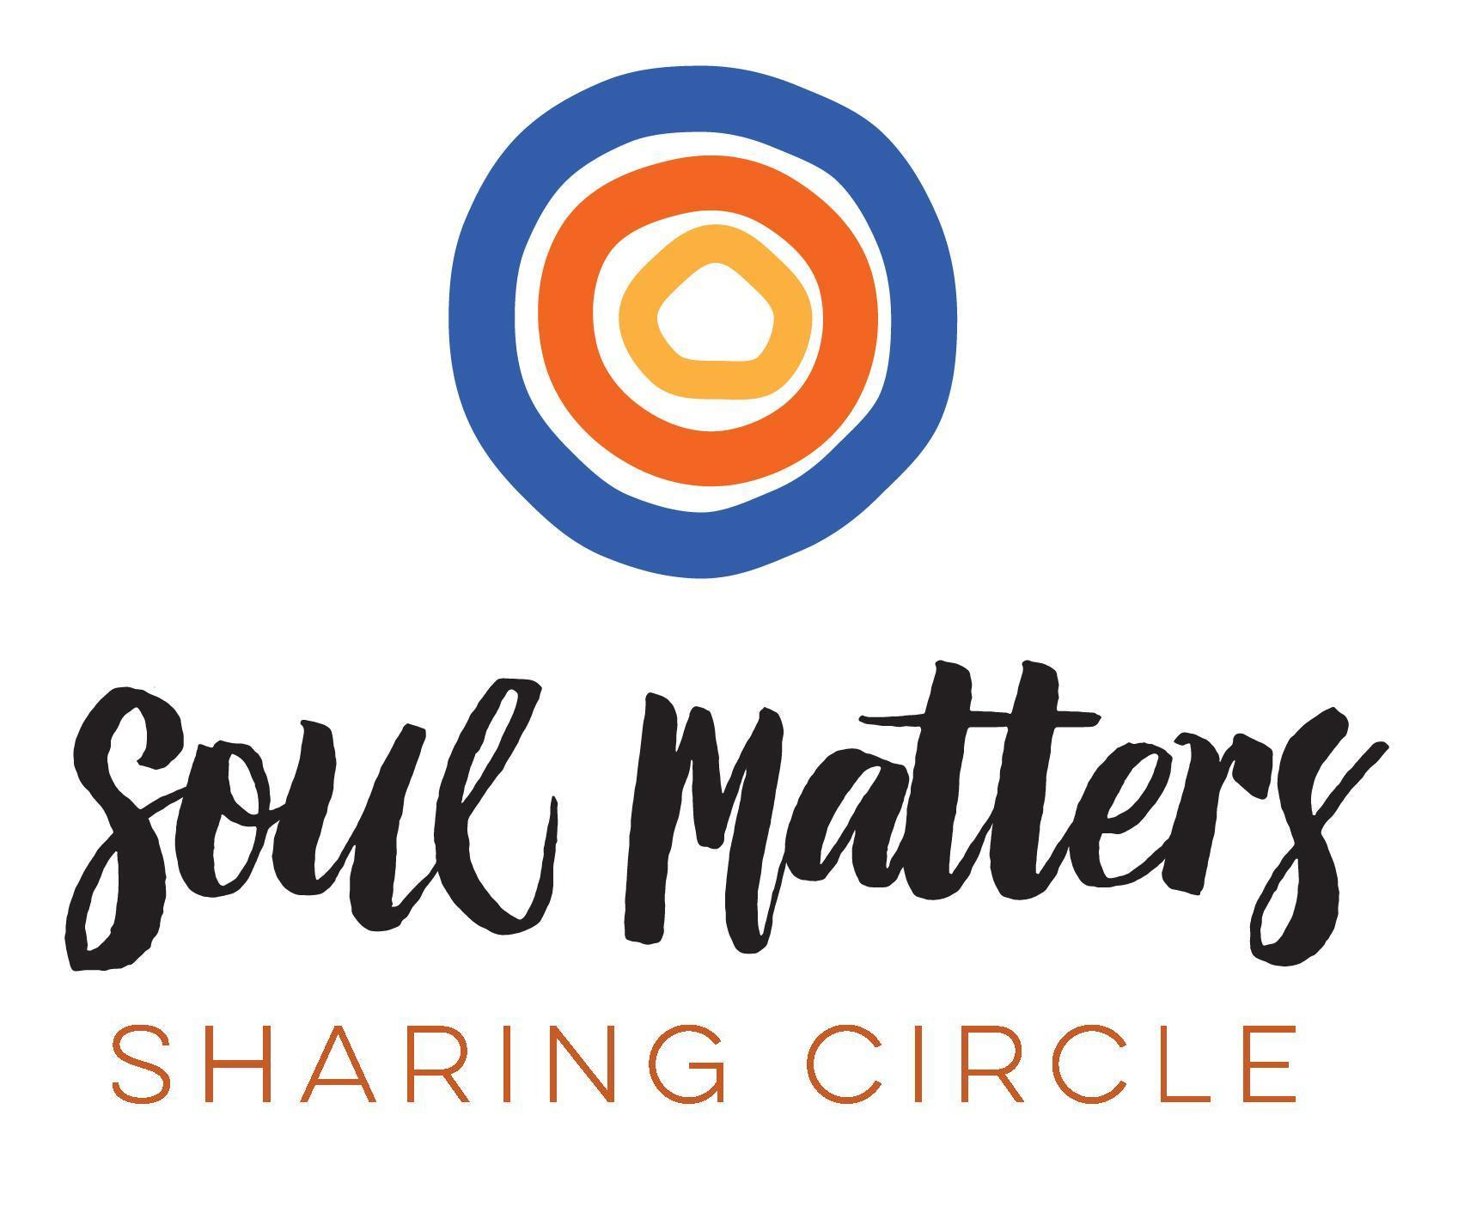
© 2025-26 Soul Matters ALL RIGHTS RESERVED
Packets are for use only by member congregations of the Soul Matters Sharing Circle.
Learn how to join at https://www.soulmatterssharingcircle.com

