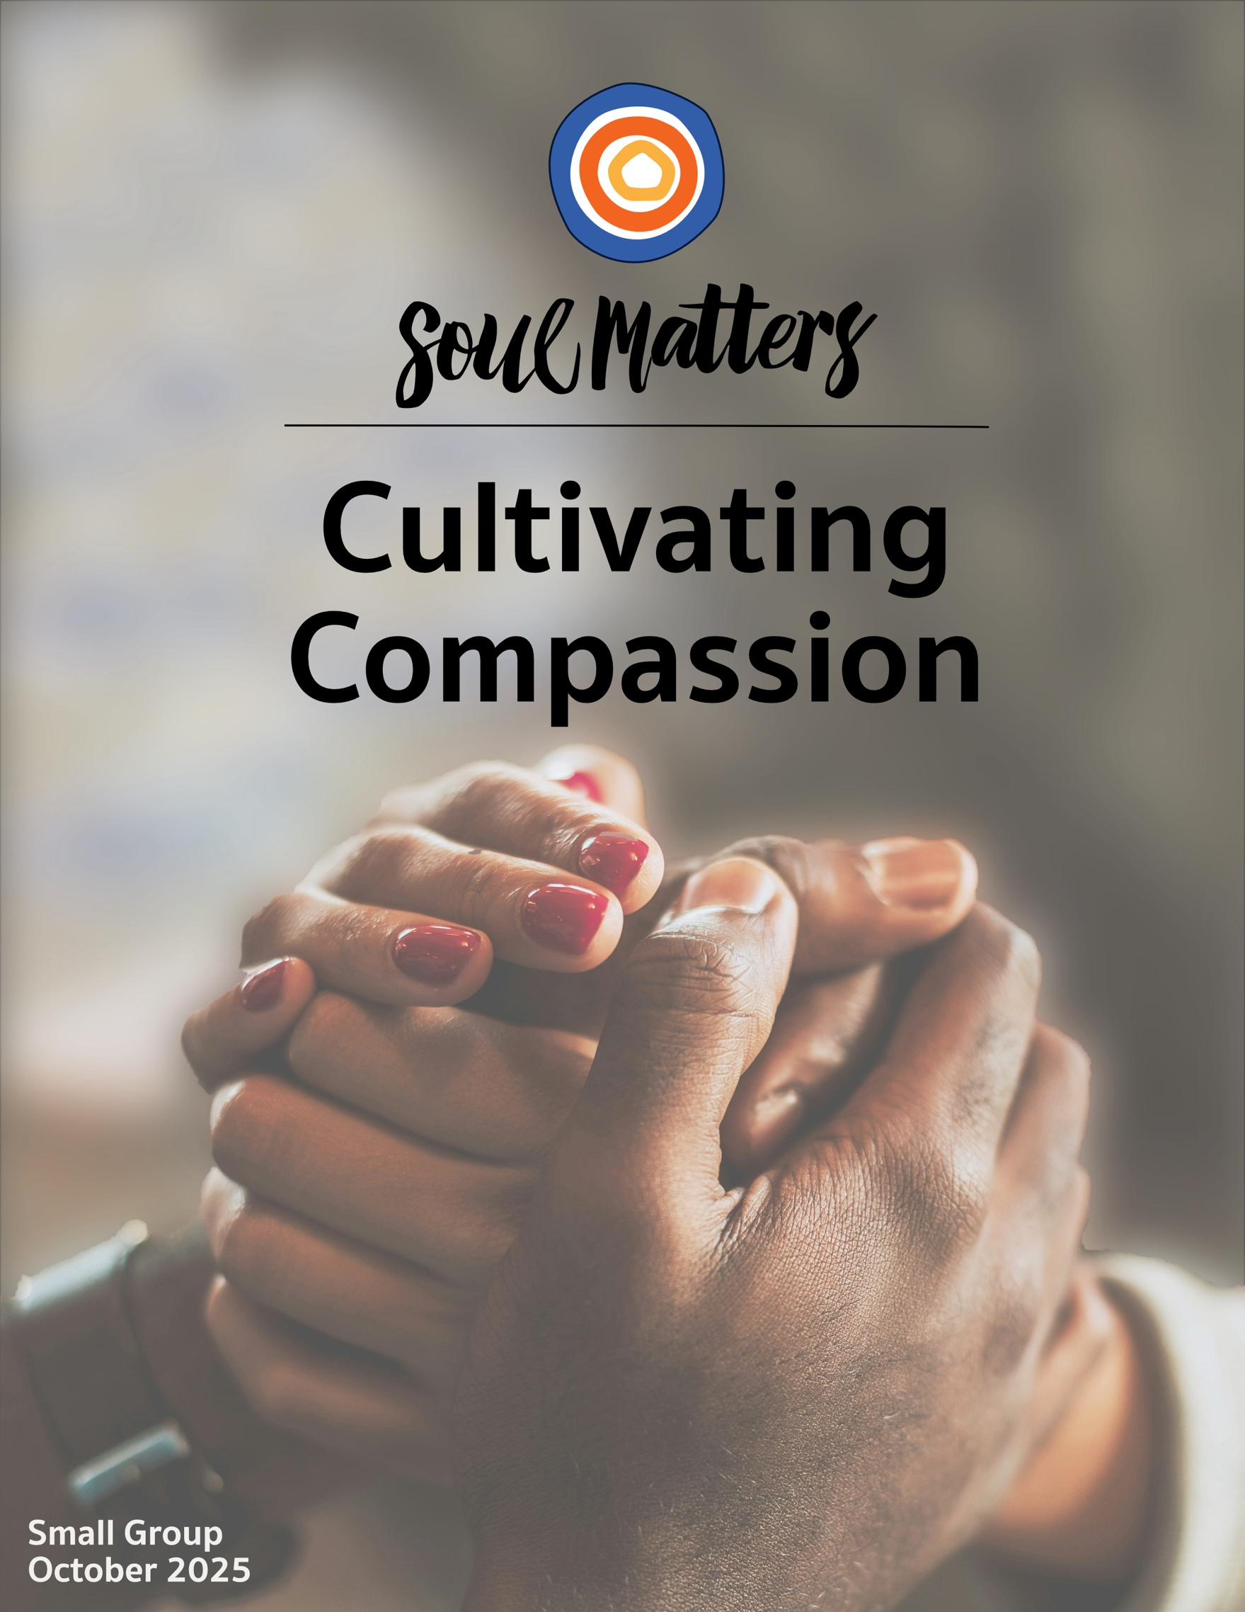

Welcome to Cultivating Compassion

It’s tempting to think of this month’s theme as one of our lighter, more pleasant ones. After all, compassion sounds…well, nice. It conjures warm feelings and tender thoughts. Images come to mind of people telling each other they are holding them in their hearts. It would seem to be all about emotional connection and empathetic feeling.

But then along comes a quote like this:

“Compassion hurts. When you feel connected to everything, you also feel responsible for everything. And you cannot turn away. Your destiny is bound with the destinies of others.” - Andrew Boyd

Or this:

“True compassion is to engage in the suffering of others.”
- The Charter for Compassion

Both remind us that compassion is not just niceness and thoughtful feelings. It’s about something deeper: an impulse that drives us to action.

Indeed, that may be compassion’s defining characteristic; it is distinguished by doing. To feel the pain of another, empathy has that covered. But compassion takes it a step further. It urges us to do something about that pain.

In other words, compassion calls us to change things! It’s not just about comforting others; it’s about our comfort getting disturbed. It’s about connecting with another’s pain and struggle so deeply that we can’t rest until they rest. When we feel compassion - real compassion - we don’t just understand another’s pain, we want it to stop. And then we do what’s needed to make it stop.

And if that’s the case, then maybe compassion’s question for us this month isn’t what we first imagined. Instead of asking us, “How deeply are you able to feel?” maybe it’s asking, “What are you prepared to do?

Spiritual Exercises
It’s one thing to analyze a theme; it’s quite another to experience it. By pulling us out of the space of thinking and into the space of doing, our spiritual exercises invite us to figure out not just what we have to say about life, but also what life has to say to us!

With that in mind, pick and complete the one exercise that speaks to you the most. Come to your group ready to share why you picked the exercise you did, how it surprised you and what gift it gave you.

Option A

Lectio Divina with Thich Nhat Hanh

Often we include spiritual exercises that draw on an ancient Christian spiritual practice called Lectio Divina, translated literally as “divine reading.” You can learn more about it here and here. The basic idea is to deeply listen to a text by reading it multiple times, through a different reflective lens or question each time.

This month, we invite you to use this lectio divina practice with one of two poems, both related to compassion.

- One poem is from the beloved Vietnamese Buddhist monk, peace activist, and teacher, Thich Nhat Hanh. It’s called Please Call Me By My True Names. This is a beautiful poem is held in high regard in the Buddhist community, but it contains a reference to sexual violence, so some may not want to engage with it.
Click HERE for the spoken version of it, which we recommend you use.
If you prefer the text version, click HERE
Before listening to the poem, read Thich Nhat Hanh’s story about the circumstances that gave rise to it HERE

- The other poem is called Dressing for the Wedding by the poet Rosemerry Wahtola Trommer
There is no spoken version, so click HERE for the text version.

Here is the lectio divina practice we invite you to use:
- Find a quiet place where you won’t be disturbed and take some time to center yourself.
- You will read/listen to the poem of your choice three times.
- For the first reading/listen, ask yourself “What FEELINGS arise as I listen to the words?” Ask yourself this question before and after you listen to/read the poem. Afterward jot down what arose for you.
- For the second reading/listen, ask yourself “What MEMORIES does this poem stir in me?” Again, ask this question before and after, and write down what arose for you.
- For the final and third reading/listen, ask yourself “What MESSAGE does this have for me?“ Or specifically, “What message of comfort or challenge is the poem trying to offer me?” On this third reading it helps to listen/look for a single word, image or phrase that pops out at you, and then apply the question to that word/phrase. Again ask this question before and after, and write down what arose for you.
- If you are up for a fourth reading, consider using this question to guide you: “Who am I in the text? Which character or action reflects what’s going on in my life right now?”

Option B

Intentional Compassion

We are mixed and complicated creatures. Our natural instinct and inclination to be compassionate sits right alongside many competing and conflicting instincts and urges. So it’s not surprising that research indicates that our desire to be more compassionate needs the support of us pairing it with a commitment to setting intentions.

So for this exercise, you are challenged to engage in some intentional compassion. The instructions are simple, even though the application is not. Basically, you are asked to take a week and begin each day by setting an intention to be compassionate in a particular way.

Here’s one way to go about it:

- Set your intention as early in the day as you can.
- Prepare yourself by finding a private space where you can center yourself by bringing awareness to your breath and calming your body.
- Think about the day ahead of you and identify likely situations you will face where greater compassion might be needed.
- Then with that in mind set an intention related to those situations you’ve identified. Your intention can be as general or specific as feels right to you. Just make sure it is connected to the situation you want to focus on. For instance, a specific one might involve committing to being more compassionate with a particular co-worker or researching a social issue so you can figure out a way to get more involved, not just think about it. Similarly, a more general intention might have to do with a habit you want to cultivate, like being more encouraging with others or being less judgmental toward yourself. Click HERE for some ideas to get you thinking.
- Write down your intention in a few words on a small card or piece of paper that you can carry with you throughout the day.
- Revisit your intention throughout the day.
- At the end of the day, reflect on how your intention impacted your day.

Option C

Your “Be Gentle with Yourself” List

Self-compassion is a skill that is not often taught or encouraged in our culture. It is treated as something we will “get around to when there is time.” This exercise has you do the opposite of “getting around to it” by inviting you to do it regularly through the month. To help you do that, we’ve created a large list of ways to be compassionate and gentle with yourself. Just print out the list and then, throughout the month, do at least five of the options. Here’s the link to that list: https://docs.google.com/document/d/1QdR-XSBTsgw3nyQF0F_8mKA9WFes1sYTfD8tujn3ftc/edit?usp=sharing

After doing the activities you’ve chosen from the list, reflect on these questions:
- Was there a common theme to the activities you picked? What might that say about your deeper longings or needs?
- Did you struggle with picking or doing any of the activities you choose? Why was that?
- Were you glad you only had to do five? Or did you wish you had time to do a lot more?
- Did you feel different after doing all the activities you picked? Did the activities lead you to viewing life, others or yourself in a different way?

Option D

Which of Your Relationships Need a Compassionate Boundary?

Numerous researchers and spiritual practitioners have made an unexpected discovery about what highly-compassionate people have in common. It’s not a uniquely strong moral sense or having grown up in a compassionate environment. It’s that they are good at establishing boundaries!

So for this exercise, we invite you to take on two tasks:

- Learn about this commonality among highly-compassionate people by watching the three videos below. If you want to dig deeper, click HERE for more resources

Interview with Brene Brown
https://www.youtube.com/watch?v=SM1ckkGwqZI&t=1s (watch only minute 44:18 - 1:06:20)

- Dr Kristin Neff on mama bear compassion
https://www.facebook.com/reel/1325396578580682

- Dr Gabor Maté on How There Is No Such Thing as “Compassion Fatigue”
https://www.youtube.com/watch?v=dI5hq5ZQ-W0

- Then apply what you’ve learned from the videos to your own life by figuring out which of your relationships need a compassionate boundary. Be sure to remember the golden rule of compassionate boundary making: It’s not about protecting yourself, but protecting the relationship.

Important Note: You may discover that identifying the relationship that needs a boundary is a hard enough step and setting the boundary is something you need a little time to take on. This is hard work, so be gentle with yourself. Challenging patterns that have been built up over many years is not an easy thing to do. And so just identifying what relationship needs changed is a major and courageous accomplishment.

Option E

Meditate on Compassion

For many, meditation and compassion go hand in hand. By setting aside time to direct our attention and thoughts in very intentional ways, meditation re-wires our brain so we are able to experience the world and interact with others differently. The Buddhist practice of metta meditation (also known as loving-kindness meditation) is one of the most well-known compassion meditative practices, but there are so many other compassion-oriented guided meditations out there.

To honor this long-established connection between compassion and meditation, you are invited to establish a daily compassion meditation practice for a week (or two) this month. To help you explore the many types of meditations out there, we’ve put together a list of diverse guided meditations to try. You can find that list by following this link: https://docs.google.com/document/d/13QPwt93L89fvmbTTfBAOXEm4B4XYWCnHkjSdqGGoVjM/edit?usp=sharing

You do not have to do all the meditations on the list. Just pick the ones that interest you most.

Option F

Ask Them About Compassion

One of the best ways to explore our monthly themes is to have conversations about them with people who are close to you. It’s also a great way to deepen those relationships! Below is a list of questions to guide your conversation. Be sure to let your conversation partner know in advance that this won’t be a typical conversation. Telling them a bit about Soul Matters will help set the stage. Remember to also answer the questions yourself as they are meant to support a conversation, not just a time of quizzing them.

Come to your group ready to share what surprised you about the conversation and what gift or insight it gave you. As always, keep a lookout for how your inner voice is trying to send you a message of comfort or challenge through these conversions with others.

Compassion Questions

- Who is to thank for the way compassion “naturally” arises in you?
- What’s your first memory of being compassionate with yourself?
- Has your self-compassion gotten harder or easier as you’ve grown older?
- If asked, would your family members say you are good at being compassionate with yourself?
- If you could magically find a way to be more compassionate with one person in your life, who would it be? And why?
- Tell me about a time when you were offered compassion in an unexpected or unique way.
- What has life taught you about navigating compassionate fatigue?
- Tell me a story about a time when compassion brought you joy.

Option G

Which Companion Piece Speaks to You?

Sometimes we come across a quote, song, article or movie and it perfectly captures what’s going on for us right
now or allows us to view our current circumstances in a new light.

With this in mind, spend some time this month going through the Companion Pieces section below to find the
one piece that speaks most powerfully to you. (Or “shimmers” most strongly for you.)

Come to your group ready to share the piece you picked, why it called to you and what insight, memory, or message of comfort or challenge it offered you.

Finding Your Question

This list of questions is an aid for deep reflection. How you answer them is often less important than the journey they take you on. So, read through the list of questions 2-3 times until one question sticks out for you and captures your attention, or as some faith traditions say, until one of the questions “shimmers.” Or as we like to say, “Read over them until one of the questions picks you.” Once you’ve identified it, go deeper by asking yourself:

- What might my inner wisdom be trying to say to me through this question?
- How might this question be trying to wake me up or get me to realize something through this question?


- Has compassion ever helped you find your way home?
- When were you offered compassion in an unexpected or unique way.?
- What’s your first memory of being compassionate with yourself?
- Who is to thank for the way compassion “naturally” arises in you?
- Where did your unkind and self-critical inner voice come from? Or maybe the better question is, whose unkind and self-critical voice taught your brain how to talk?
- What do you need to do to stay tender and compassionate in the face of our consistently cruel political culture that wants you to go numb?
- Which of these self-diminishing cultural lies do you struggle with the most, maybe without even realizing it: 1. I am what I have, 2. I am what I do, 3. I am what other people say or think about me, 4. I am nothing more than my worst moment?
- Is it possible that your self-improvement efforts have subtly become acts of self-aggression?
- How would your feelings about and actions with that “difficult person” in your life change if you somehow discovered they were doing the best they can or that their aggravating behavior is not a character defect but a wound that runs deep?
- In a world that needs so much compassion, many of us feel tangled up in and worn down by compassion fatigue. How might that struggle be eased if you more regularly asked yourself: What's mine to do? What’s not mine to do? What’s mine to say? What’s not mine to say? What’s mine to care about? What’s not mine to care about?
- Is it time to stop beating yourself up for that poor decision you made long ago? Is it time to remind yourself that you made the best decision you could have with the information and skills you had at the time?
- What if your busy and important life is the true enemy of your compassion?
- What’s your question? Your question may not be listed above. As always, if the above questions don't include what life is asking from you, spend the month listening to your days to find it.

Companion Pieces
Recommended Resources for Personal Exploration & Reflection
The following resources are not required reading. Nor are they intended to be analyzed in your group.
Instead, they are here to companion you on your personal journey this month, get you thinking
and open you up to new ways of embodying this month’s theme in your living and loving.

Wise Words

There is a hierarchy of responses when we encounter suffering. Pity says, “I see your pain.” Sympathy says “I understand your pain.” Empathy says, “I feel your pain.” Compassion says “I am with you in your pain and I will help.”
Rabbi Esther Adler

We were all broken from the same nameless heart, and every living thing wakes with a piece of that original heart aching its way into blossom. This is why we know each other below our strangeness, why when we fall, we lift each other, or when in pain, we hold each other, why when sudden with joy, we dance together. Life is the many pieces of that great heart loving itself back together.
Mark Nepo

True compassion is more than flinging a coin to a beggar; it understands that an edifice that produces beggars needs restructuring.
Martin Luther King Jr.

Compassion is not a relationship between the healer and the wounded. It's a relationship between equals. Only when we know our own darkness well can we be present with the darkness of others. Compassion becomes real when we recognize our shared humanity.
Pema Chödrön

Hurt people, hurt people… but, they help them too.
Iain Corbett

We are being conditioned to shut down. The barrage of cruelty, confusion, spectacle, and spin… wears on our capacity to feel… That is the danger of this moment—not just political collapse or climate unraveling or the erosion of public trust—but the numbing of our souls…
Rev. Cameron Trimble

Self-compassion isn’t about escaping your darkness but learning to love yourself there.
Jennifer Healey

Having compassion for yourself means that you honor and accept your humanness.
Kristen Neff

If your compassion does not include yourself, it is incomplete.
Jack Kornfield

Hold yourself as a mother holds her beloved child.
The Buddha

She doesn’t want to wear short sleeves, she says,
because they will show her “old woman arms.”
Sometimes worry is just another word
for wanting to be loved just as we are…
Rosemerry Wahtola Trommer

Compassion is not foolish. It doesn’t just go along with what others want so they don’t feel bad. There is a yes in compassion, and there is also a no, said with the same courage of heart… Buddhists call this the fierce sword of compassion. It is the powerful no of leaving a destructive family, the agonizing no of allowing an addict to experience the consequences of his acts.
Jack Kornfield

You are not required to set yourself on fire to keep others warm.
Unknown

When you avoid conflict to make peace with other people, you start a war within.
Cheryl Richardson
Those who do the most growing in this life are those who offer the most compassion to the parts of themselves that have not yet grown.
Andrea Gibson

We must admit—compassion is not always easy. Still, we choose it. Not because the world is kind, but because we can be.
David Breeden

Have compassion for everyone you meet,
even if they don’t want it. What seems conceit,
bad manners, or cynicism is always a sign
of things no ears have heard, no eyes have seen.
You do not know what wars are going on
down there where the spirit meets the bone.
Miller Williams & sung by Lucinda Williams

Stripped of violent reaction, anger is the purest form of care, the internal living flame of anger always illuminates what we belong to, what we wish to protect and what we are willing to hazard ourselves for.
David Whyte

Shoulders
Naomi Shihab Nye
Text: https://poets.org/poem/shoulders
Spoken: https://www.youtube.com/watch?v=mKDuDTCJtgU

Videos & Podcasts

Small Kindnesses, Danusha Laméris
https://www.youtube.com/watch?v=klfbqElrf7Y&list=RDklfbqElrf7Y&start_radio=1

Short Film: The Wait
https://www.youtube.com/watch?v=EuRHHmXbzYs

On Quiet as the Doorway to Compassion
https://www.youtube.com/watch?v=OkHypImEY84

Please Call Me By My True Names, Thich Nhat Hanh
https://www.youtube.com/watch?v=sI5LK3SzkCM

Bryan Stevenson on The Gift of Shared Brokenness
https://www.instagram.com/reel/DLSQsbKhQc6/

Compassion Fatigue: The Cost of Vicarious Trauma
https://www.youtube.com/watch?v=ZsaorjIo1Yc

How To Keep Caring Amid Endless Crises
https://slate.com/podcasts/how-to/2024/01/how-to-keep-caring-amid-endless-crises

Being Kind to Yourself, Hidden Brain interview with Dr. Kristin Neff

https://hiddenbrain.org/podcast/being-kind-to-yourself/

It Is Entirely Possible For A Black Girl To Be Loved
A beautiful example of claiming self-compassion for yourself.
https://www.youtube.com/watch?v=Wy_XyUpIazU

Why Compassion is the Ultimate Life Hack
https://www.youtube.com/watch?v=jSAzyOokLaY

The Five Levels of Compassion, Dr Gabor Maté
https://www.youtube.com/watch?v=uzrqbrWLBaM

The Urgent Need for Compassion, The Man Enough Podcast
https://www.youtube.com/watch?v=Tq3C9R8HNUQ

The Heart of Compassion, Cynthia Bourgeault
https://www.youtube.com/watch?v=dl8qaVRiK5U
On how compassion arises out of oneness and refusing to see ourselves as the helpers and others as the “helpees.”

What Love Is, Andrea Gibson
https://andreagibson.substack.com/p/what-love-is
On when compassion is hard.

Music
Our thematic playlists - on Spotify and YouTube - are organized as a journey, so consider listening from beginning to end and using them as a personal musical meditation.

Click here for the Spotify playlist on Cultivating Compassion
Click here for the YouTube playlist on Cultivating Compassion

Books

The Emperor of Gladness (interview)

Trauma Stewardship: An Everyday Guide to Caring for Self While Caring for Others

Self-Compassion: The Proven Power of Being Kind to Yourself
Fierce Self-Compassion: How to Harness Kindness to Speak Up, Claim Your Power, and Thrive

Movies

The Farewell
All We Imagine As Light
Roma
Daughters
Hard Truths
Night Comes On
Billy & Molly: An Otter Love Story
My Octopus Teacher
Won’t You Be My Neighbor?

More Monthly Inspiration from Soul Matters!

Our Facebook Inspiration Page: https://www.facebook.com/soulmatterssharingcircle/
Our Instagram Page: “soul_matters_circle”

Packet Introduction Credit Note: Unless explicitly noted otherwise, the introductions of these packets are written by our Team Lead, Rev. Scott Tayler. Rev. Scott gives permission for his pieces to be used in any way that is helpful, including in newsletters, worship and online service/recordings.


© 2025-26 Soul Matters ALL RIGHTS RESERVED
Packets are for use ONLY by member congregations of the Soul Matters Sharing Circle.
Learn how to join at https://www.soulmatterssharingcircle.com

